Emory Clinics Reactives Linking and Flipping to Pending Approval SOP v 9.16.25

**You will only review accounts/visits that are in the Emory Clinics-Reactive ID Name**

Examples
- If there are not any open applications, you will update the report with the following;
- New Visit Status (Column U): Upadate from the Status for Hold to No
- New Visit Detail (Columns V): Update with status of Not Eligible

- Open T16 application or Aged SSI (not in a closed status)
- Include applications with a status of Pending, Application Taken, Or Taken Not Sent meet the following criteria;
- that are on or after the Emory Reactive admit date
- There is an Emory or Dekalb non-reactive ID acct that has the same admission date as the Reactive acct
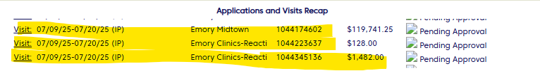
- If there are accounts that are not linked to the open T16 application, you will need to link them by performing the following steps;
a)Review to see if there are any accounts/visits under the Unlinked Active Visits hyperlink and Unlinked Visits. Make sure that you select the to open the drop down of Active unlinked visits.
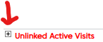 and
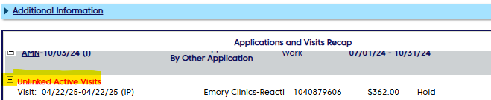

b) On the PACE menu bar, select Link under the Visits menu option
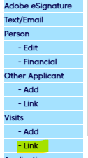
c) Update the Status from Hold to Pending Approval and Select Save
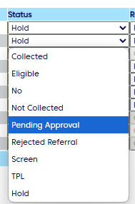
- If there is not an open T16 application, then you will review to see if there is an open State application(AMN, RSM, LIM)
- There is an Emory or Dekalb non-reactive ID acct that has the same admission date as the Reactive acct

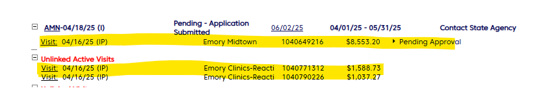
- EMA State application(EMA-AMN, EMA-RSM, EMA-LIM)
- Account/Visit has to be IP only. EMA does not cover OP accounts
- If the IP account is linked to an open EMA application, then update the New Visit Status(Column U) from Hold to Pending Approval in PACE.
- If the account is not linked to an open EMA application, review to see if there are any accounts/visits under the Unlinked Active Visits hyperlink and Unlinked Visits. Make sure that you select the to open the drop down of active unlinked visits.
and
- b) On the PACE menu bar, select Link under the Visits menu option
c) Update the Status from Hold to Pending Approval and Select Save
- For EMA applications, if there are not any open applications, or, the account is an OP visit, you will update the report with the following;
- New Visit Status (Column U): Upadate from the Status for Hold to No
- New Visit Detail (Columns V): Update with status of Not Eligible

